**Company Profile:**

Staples is a large American retail company specializing in office supplies and related products and services. It's known for its extensive range of office supplies, business technology, furniture, and facility products.

**Business Process :**

In a typical large retail organization like Staples, the business process might involve supply chain management, inventory control, sales and marketing, customer service, and financial management. The Target Information System (IS) would likely include systems for enterprise resource planning (ERP), customer relationship management (CRM), and point of sale (POS) systems.

**Project Name:**

Staples

**Project Definitions:**

This involves outlining the scope, objectives, deliverables, timeframes, and resources required for a specific project. For example, a project could be defined to upgrade network security or to implement a new online ordering system.

**Project Organization:**

Projects at Staples, like in many large organizations, are likely organized under a project management office (PMO) or similar structure. This includes a team of project managers, coordinators, and other professionals who oversee various project aspects from planning to execution.

**Network Layout:**

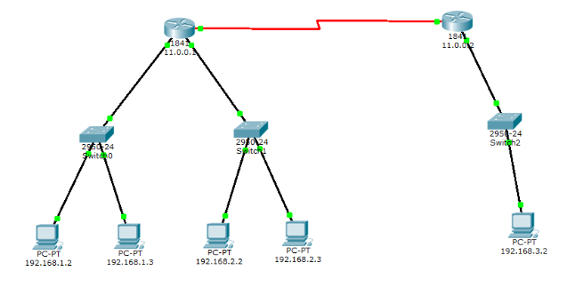

**Malware Issue (Possible Virus):**

Any large company is susceptible to malware and virus threats. Staples would likely have robust cybersecurity measures in place, including firewalls, antivirus software, intrusion detection systems, and regular security audits to mitigate these risks.

**Proposed Information Assurance:**

Information assurance in a company like Staples would encompass protecting the integrity, availability, authenticity, and confidentiality of information. This might involve implementing strict access controls, data encryption, secure communication protocols, regular security training for employees, and compliance with relevant data protection regulations.

**Physical Access Control:**

This includes measures to prevent unauthorized physical access to Staples' facilities. Methods may include key card systems, security personnel, and entry protocols.

**Physical Security:**

Physical security at Staples likely involves surveillance cameras, alarm systems, and security personnel to protect assets, staff, and sensitive information from physical threats.